Instruction:

Complete all questions in 1 hour.

1. Start the "Command Prompt" from the Windows Start Menu (Start -> Accessories -> Command Promtp).

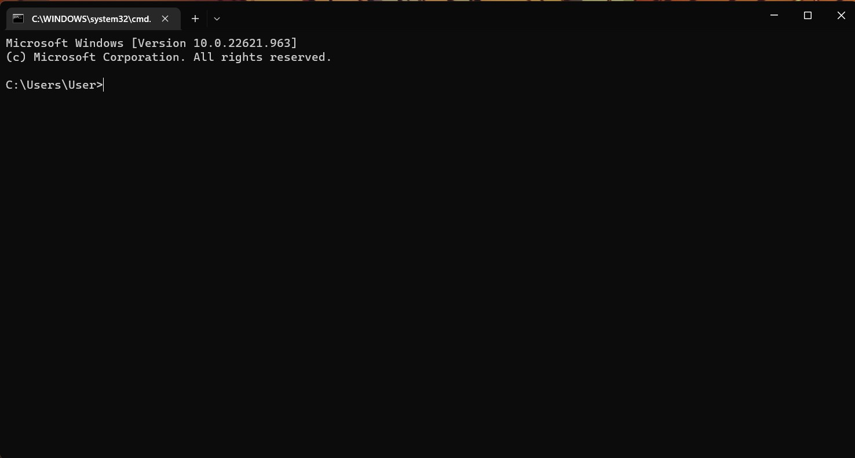

1. Use cd, cd.., cd/.. commands to navigate through the directories.

Create the Directory HCK on the desktop.

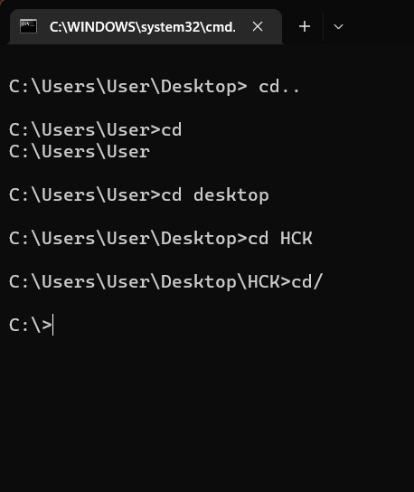

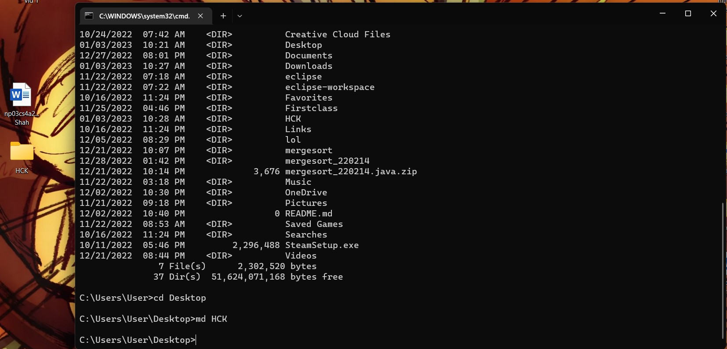

1. List the files in the current directories. Make use of commands cls, exit to clear the screen and exit the prompt.

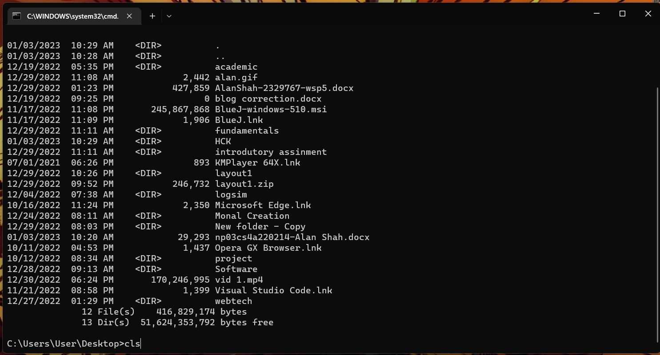

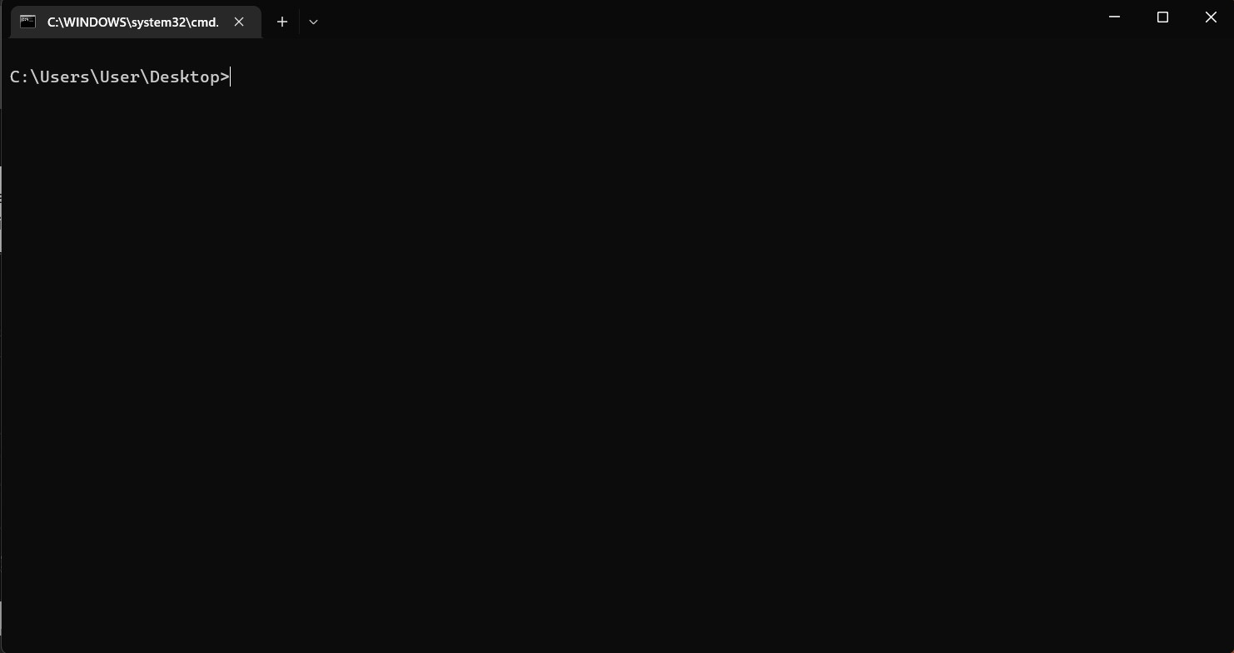

1. Create a New.txt file containing the text *“Herald College Kathmandu”*, in the HCK directory.

1. Delete the New.txt file from the HCK directory.

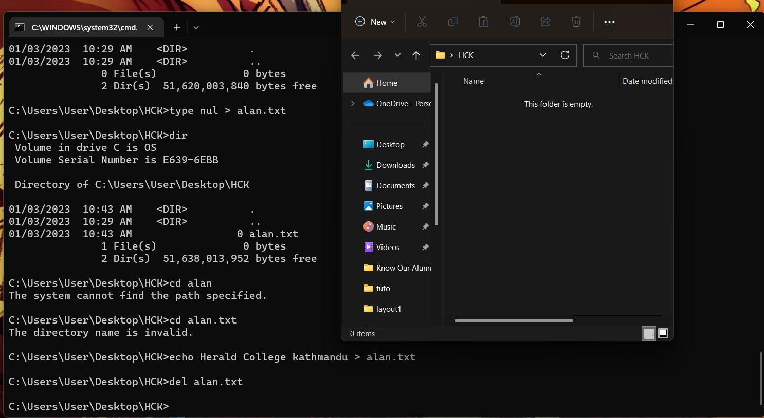

1. Remove the directory HCK from the Desktop.

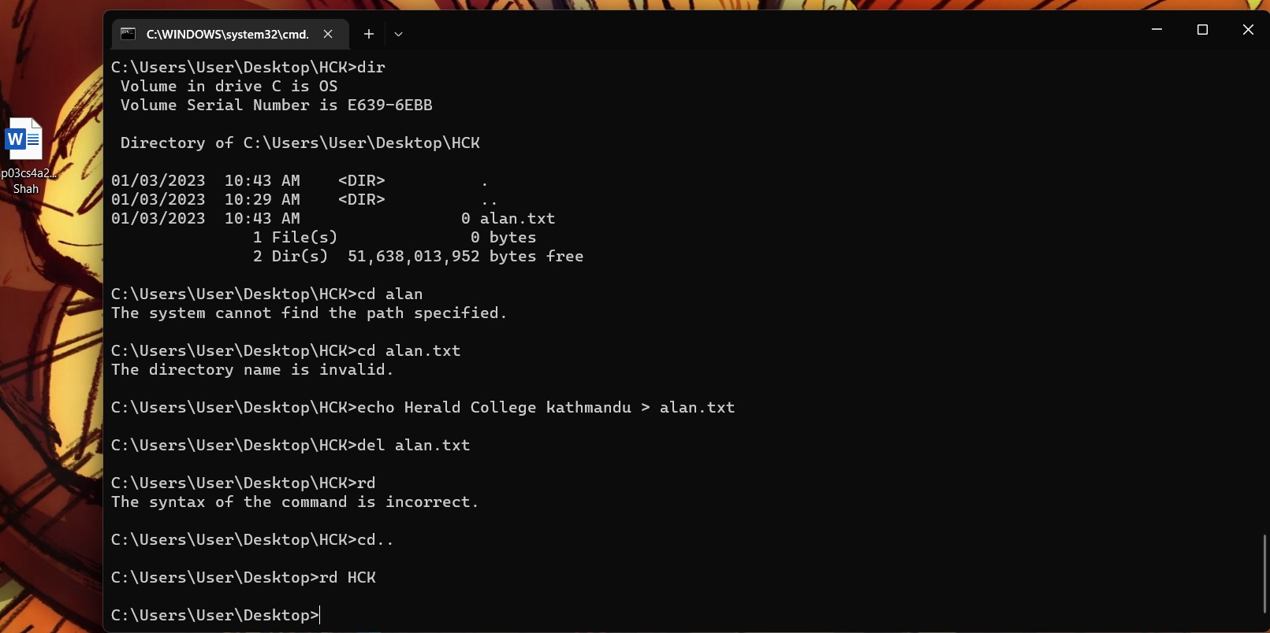

1. Create a directory Kathmandu on the desktop containing file

Swyambhu.txt,

Rename Swayambhu.txt as Barahi.txt

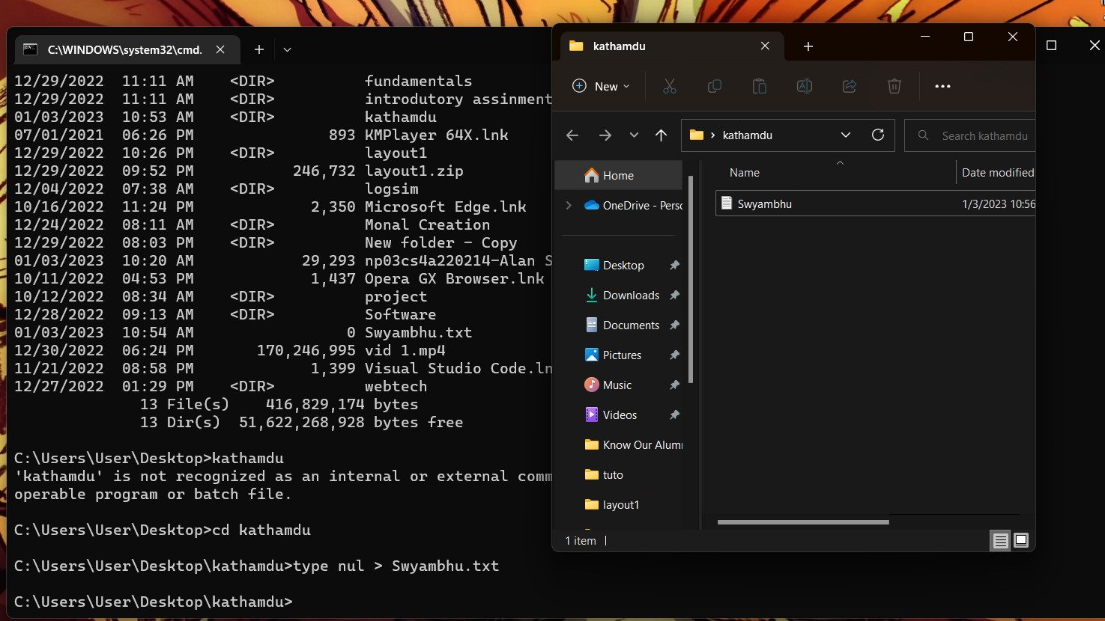

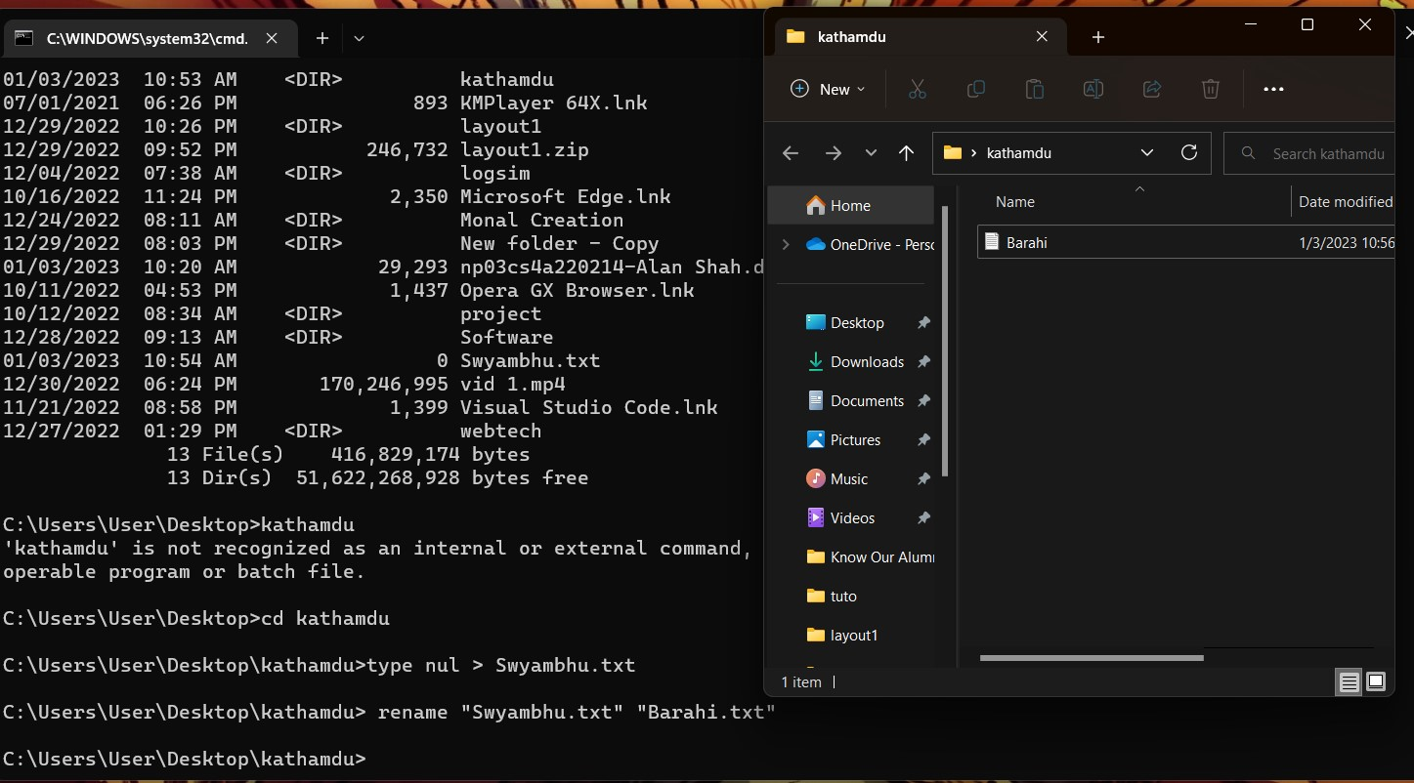

1. Create Directory Pokhara on the Desktop and move Bahari.txt of the directory Kathmandu to the directory Pokhara.

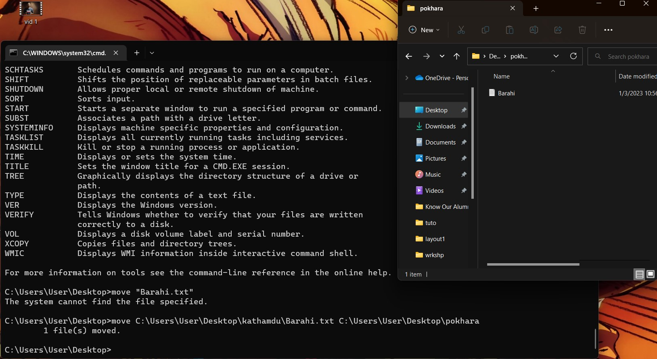

1. Write the python program in IDLE which takes two inputs from the user and returns the sum of the two numbers. Run this program from the command prompt.
2. Run the logsim program from the command prompt.

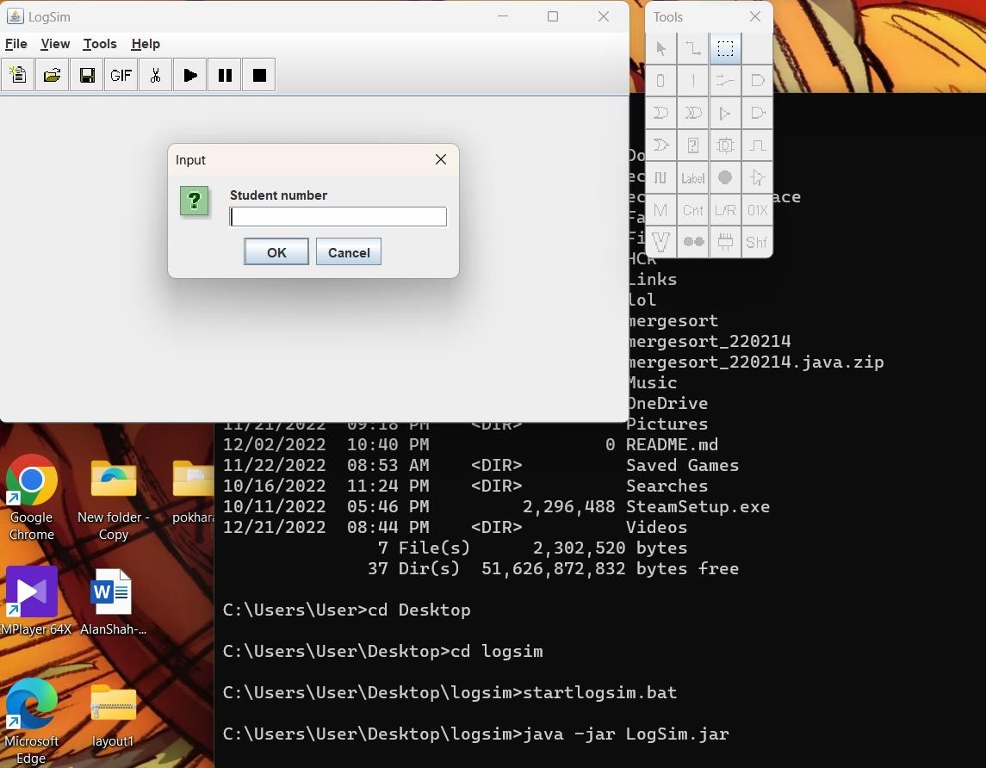

1. Create the following structure and take a Screenshot. Paste your result here.

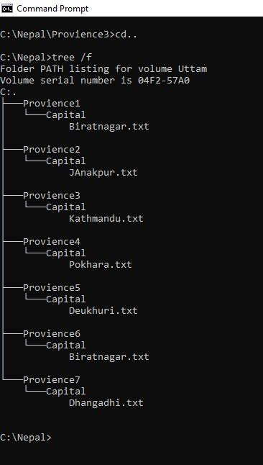

For more details about Commands you can type ***Help***which lists all the internal commands:

